7.G Take Home Quiz Name ___________________________

Grid | Problem | Work
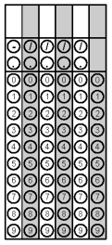 | The circumference of a circle is 144 meters. What is the radius of the circle to the nearest whole number?
Find the value of a if the perimeter of the figure below is 41 units.

4a + 5

15 - a

What is the area of the window below to the nearest TENTH?

14ft

12 ft

 | What is the area of a circle with a diameter of 25 inches?
 | How many square feet of fabric would be needed for a tent (triangular prism) if its base measures 4ft, the height is 5ft, and the length is 8ft?

