Name: ____________________________
Homework – Monday (April 25, 2016)
Solve the following problems without a calculator. You MUST show your work. NO WORK = NO CREDIT.
1. Destiny made a snack mix using the ingredients listed below.  1 ¼ cups granola ½ cup raisins ½ cup raisins ¼ cup chocolate chips  What is the total amount of all four ingredients? | 2. Brooks saved $25.40. Raven saved ¾ of the amount that Brooks saved. Nylah saved twice as much as Raven. How much is the total saved of all three?
3. During one week, Stephanie made several changes to her bank account. She made four withdrawals of $40 each from an ATM. She also used her check card for a $156 purchase. Then she deposited her paycheck of $375. By how much did the amount in her bank account change during that week? | 4. A kindergarten class is making clay animals for a play. The teacher has 2 ¾ gallons of clay. Each child needs 1/16 of a gallon to make an animal. How many children can make a clay animal?

Homework- Tuesday (April 26, 2016)
Solve the following problems without a calculator. You MUST show your work. NO WORK = NO CREDIT.
1. The sum of a number, n, and 8 is multiplied by -4, and the result is -12. What is the number? | 2. Camille spent $25 at the store. She paid $10 for a shirt and spent the rest of her money on 3 necklaces. Each necklace cost the same amount of money. Write an expression to find n, the price of each necklace.
3. Julie works Sunday, Monday, and Wednesday for 10 hours each day. On Tuesday, Thursday, and Friday, she works 7 hours each day. She does not work on Saturday. Her weekly total earnings are $612. What is her hourly rate of pay? | 4. Solve and graph the solution set for the following inequality.  3x + 4 < -18  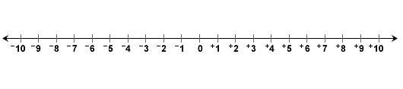
Homework - Wednesday (April 27, 2016)
Solve the following problems without a calculator. You MUST show your work. NO WORK = NO CREDIT.
1. A runner jogged 5 ¼ miles in 45 minutes. At this rate how far will she run in 2 hours? | 2. A satellite is 18 meters wide. A model of it was built with a scale of 1 centimeter : 3 meters. How wide is the model?
3. Outside of the school, there is a flag pole that is 36 feet in height. It casts a shadow that is 36 feet long. Standing in front of the pole is a boy who is 6 feet tall. What will be the length of his shadow? | 4. During cooking, chicken loses 10% of its weight due to water loss. In order to obtain 1,170 grams of cooked chicken, how many grams of uncooked chicken must be used?

Homework - Thursday (April 28, 2016)
Solve the following problems without a calculator. You MUST show your work. NO WORK = NO CREDIT.
1. What is the approximate volume of the cylinder?  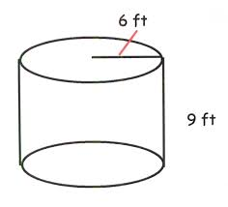 | 2. A bicycle training wheel has a radius of 3 inches. The bicycle wheel has a radius of 10 inches. Approximately how much smaller, in square inches, is the area of the training wheel than the area of the regular wheel?
3. △XYZ has side lengths of 15 m, 20 m, and 25 m. What are the side lengths of a triangle similar to △XYZ whose shortest side is 3 m? | 4. The scale drawing of a rectangular room has a length of 18 inches and a width of 12 inches. If the scale for the drawing is 1 inch = 2 ½ feet, what is the perimeter of the actual room?

