Name: ____________________________
Homework – Monday (April 4, 2016)
Solve the following problems without a calculator. You MUST show your work. NO WORK = NO CREDIT.
1. Find the sum.  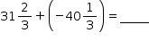 | 2. Chayse has 3 packages of drink mix and 2 bottles of lemonade. Each package makes 64 ounces of lemonade. Each bottle contains 48 ounces. How many 6-ounce glasses of lemonade can she serve?
3. What is the value of the expression below?  8.5 - 10.2 + (-7.4) | 4. On Monday, CJ’s checking account held $61.72. On Tuesday, he withdrew $57.00 from the account. On Thursday afternoon he deposited $197.27. What was his final balance Friday morning?

Homework- Tuesday (April 5, 2016)
Solve the following problems without a calculator. You MUST show your work. NO WORK = NO CREDIT.
1. A farmer is building a rectangular pen. The length is 20 feet longer than the width. What is the largest value the length can be in order for the perimeter to be at most 760 feet? | 2. What is the value of the inequality?  x - 9 < -7  3
3. Jamaya buys a book for $12 and a DVD for $15. DVD’s are on sale for 20% off. Sales tax is 7%. What is the total cost of Jamaya’s purchases? | 4. Write an equivalent expression.  4 (-15 - 3p) - 4 (-p + 5)
Homework - Wednesday (April 6, 2016)
Solve the following problems without a calculator. You MUST show your work. NO WORK = NO CREDIT.
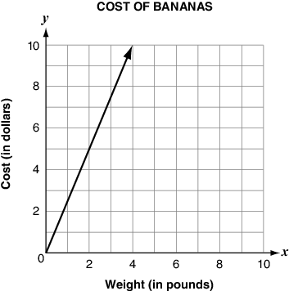  1. The graph shows the cost of bananas at a supermarket based on the weight of the bananas in pounds. What is the cost of 1 pound of bananas? | 2. Are 2/15 and 3/30 proportional?
3. A cookie recipe requires ¾ cup of flour to 1 ½ dozen cookies. How much flour is needed to make 1 dozen cookies? | 4. Jaxon put a 12 inch tall bucket under a leak in his sink. The bucket fills at a constant rate of ½ inches every ⅙ of an hour. How many hours will it take to fill the bucket?

Homework - Thursday (April 7, 2016)
Solve the following problems without a calculator. You MUST show your work. NO WORK = NO CREDIT.
1. Find the surface area of the cylinder.  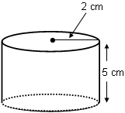 | 2. The area of a circle is 64π cm². What is the diameter of the circle?
3. The supplement of an angle is thirty more than twice the angle. Find the measure of the angle and its supplement. | 4. Find the area of the shaded region.  