Name: ____________________________
Homework – Monday (May 16, 2016)
Solve the following problems without a calculator. You MUST show your work. NO WORK = NO CREDIT.
1. With the help of her science teacher, Krista is doing an experiment on the effect of low temperatures on bacteria. She cools one sample of bacteria to a temperature of -51°C and another to -76°C. What was the temperature difference in the two experiments? | 2. During the football game, Justin caught three passes. One was for a touchdown and went 52 yards. The other was for a first down and was for 17 yards. The other was on a screen pass that did not work so well and ended up a gain of -10 yards. What was the total yardage gained by Justin on the pass plays?
3. Solve. (Round to the nearest tenth.)  8 ÷ (8 ÷ 13) + 53 + 6 | 4. At the end of the first quarter, 1/9 of the 7th graders received an A, 1/6 of the 7th graders received a B, 1/3 of the 7th graders received a C, and the rest received a D. If there are 108 students in the 7th grade, how many students received a D?

Homework- Tuesday (May 17, 2016)
Solve the following problems without a calculator. You MUST show your work. NO WORK = NO CREDIT.
1. Online basketball tickets cost $24 each, plus a service charge of $6.50 per ticket. The Web site also charges a transaction fee of $12.95 for the purchase. You paid $235.49. How many tickets did you buy? | 2. Which set contains only ordered pairs that satisfy the equation 4 - 3x < -2?  - {2.5, 8, 15}  - {8, 0, 1.5}  - {-15, 8, 0}  - {0, 2.5, 8}
3. Kyrion spends $450 on monthly bills. Of this total amount, 12% is for phone service, 1/10 is for Internet service, and 2/9 is for utilities. If the rest of the total amount is for food, how much does Kyrion have for food? | 4. Solve and graph the solution set for the following inequality.  12 - x < 8  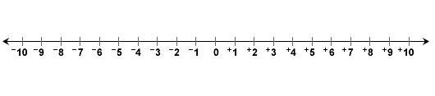
Homework - Wednesday (May 18, 2016)
Solve the following problems without a calculator. You MUST show your work. NO WORK = NO CREDIT.
1. A local college recently reported that enrollment increased 108% of last year. If enrollment last year was at 17,113, about how many students enrolled this year? | 2. A heart typically beats 4,320 times in an hour. At this rate, how many times does a heart beat in 8 minutes?
3. A 4 ft tall tent casts a 28 ft long shadow. How long is the shadow of a 9 ft tall adult elephant? | 2. A customer bought a package of 12 cookies for $5.40 at a bake sale. The customer also bought additional cookies at $0.50 per cookie. If the total cost of the cookies was $8.40, how many total cookies were purchased?

Homework - Thursday (May 19, 2016)
Solve the following problems without a calculator. You MUST show your work. NO WORK = NO CREDIT.
1. What is the approximate circumference of the circle that has a center at (2, 1) and passes through the point  (2, 5)? | 2. Find the surface area of the cube.  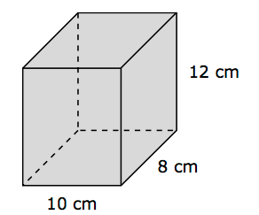
3. What is the approximate area of the shaded region? (Round to the nearest tenth.)  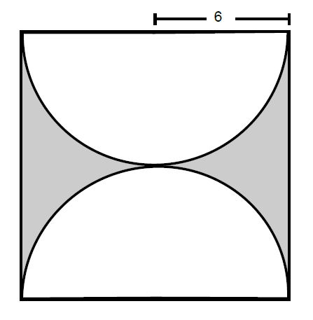 | 4. Mekiah’s bathroom floor is 5 feet wide and 8 feet long. She will cover the floor with 3-inch square tiles. How many tiles does Mekiah need?

