Name: ____________________________
Homework – Monday (May 2, 2016)
Solve the following problems without a calculator. You MUST show your work. NO WORK = NO CREDIT.
1. Mrs. Tanner had 24 guests at her house for a party. Each guest brought one item.  - One-third of the guests brought drinks.  - One-fourth of the guests brought a dessert.  - The rest of the guests brought chips.  How many guests brought chips? | 2. Solve.  [-10(-0.9)] – [(-10) • 0.11]
3. The temperature was -3℃ on Friday and dropped overnight by 9℃. What was the temperature on Saturday morning? | 4. A kitchen is shaped like a rectangle with dimensions of 11 ½ ft by 9 ½ ft. The floor of the room is made of square tiles with a side length of ½ ft. What is the number of tiles that will cover the kitchen floor?

Homework- Tuesday (May 3, 2016)
Solve the following problems without a calculator. You MUST show your work. NO WORK = NO CREDIT.
1. Write an equivalent expression.  -4 (x + 2) - ½ (2x - 6) | 2. Abby saved $25 in a jar each month for 1 ½ years. She spent 75% of her savings on a new purse. How much money did Abby have left in the jar?
3. Mr. Caldwell spent $156 to attend a UNC football game.  - Twenty percent of this cost was for a parking pass.  - He spent the remainder of the money on two tickets for the game.  What was the price per ticket? | 4. Solve and graph the solution set for the following inequality.  -3x - 12 > 3  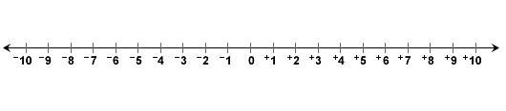
Homework - Wednesday (May 4, 2016)
Solve the following problems without a calculator. You MUST show your work. NO WORK = NO CREDIT.
1. Jordan makes pies. To make 6 pies, he uses 7 ½ cups of flour. How many cups of flour are needed to make 1 pie? | 2. A notebook costs $4.50 plus sales tax. After sales tax, the notebook is $4.86. What is the sales tax rate?
3. Ms. Wright earns $250 per week working at the Coach store. In addition, she earns 2% commission on all of her sales. Last week, she sold $2,800 worth of purses. What was Ms. Wright’s total income for the week? | 4. Ernesto mixed ¾ liter of yellow paint with 1 ¼ liters of red paint to make 2 liters of orange paint.  - He needed more orange paint.  - To make a new batch of orange paint, he used exactly 1 liter of red paint.  Using the same ratio, how many liters of yellow paint should Ernesto use to make the new batch of orange paint?

Homework - Thursday (May 5, 2016)
Solve the following problems without a calculator. You MUST show your work. NO WORK = NO CREDIT.
1. Find the volume of the rectangular prism.  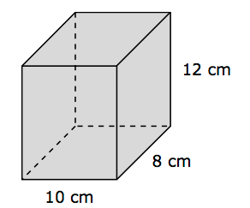 | 2. Angles A and B are complementary. Angle A has a measure of (2x + 10). Angle B has a measure of 48. What is the value of x?
3. The measure of angle ABD is 110 degrees. What is the measure of angle CBD?  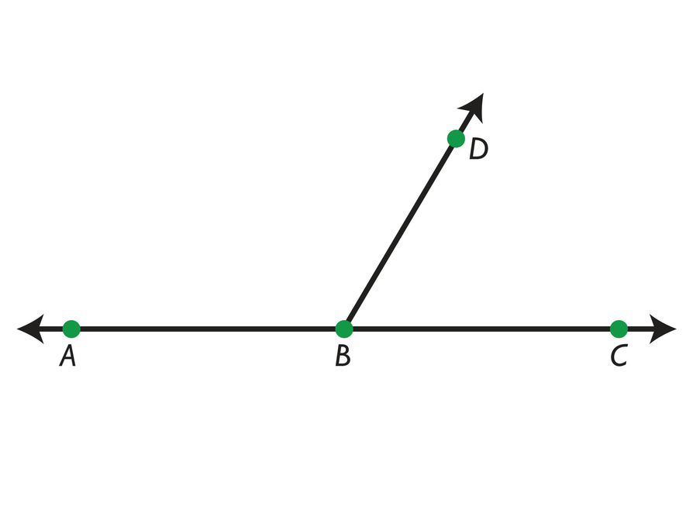 | 4. The scale drawing of a rectangular room has a length of 18 inches and a width of 12 inches. If the scale for the drawing is 1 inch = 2 ½ feet, what is the perimeter of the actual room?

